Experiment no:19

AIM:

Simulating X, Y, Z Company Network Design and simulate using Packet Tracer

REQUIREMENTS:

1. End device - They are the devices through which we can pass message from one device to another and they are interconnected.

2. Switch/Hub - Interface Between two devices.

3. Cable - Used to connect two devices.

4. pc

5. router

Procedure:

STEP 1: Click on end devices, select generic Pc’s drag and drop about 20 pc’s on the

window. Click on SWITCH drag and drop it on the window. and also connect the server to the switch.

STEP 2: Select the straight through cable and connect all end device to switch. Assign the IP address for all end devices. (Double click the end device Select →

desktop → IP configuration static)

STEP 3set the ip address for server from server click services and assign the ip to 10 (last digit) and save. Now click on each pc and check its dhcp status by clicking it and ip address is assigned automatically.

STEP 5: To view the IP address, give ipconfig command in command prompt. Using ping command, we can establish communication between two host devices.

STEP 6: Now display the packet transmission in simulation mod

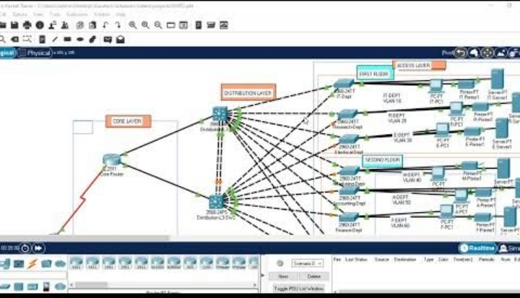

Result

the configuration of x,y,z simulation is successful